Algebraic Methods- Questions
Jan 2013 Mathematics Advanced Paper 1: Pure Mathematics 4

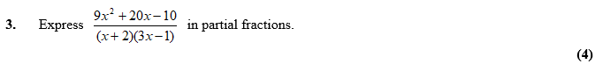

June 2011 Mathematics Advanced Paper 1: Pure Mathematics 4

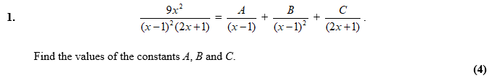

June 2010 Mathematics Advanced Paper 1: Pure Mathematics 4

